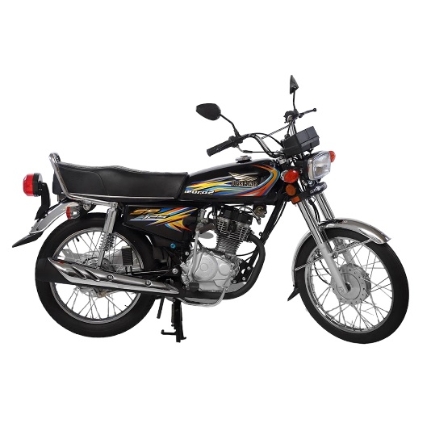

Super Power Euro2 Black 125cc Bike (Karachi Only) 7-10 working days

Product details of Super Power Euro2 Black 125cc Bike (Karachi Only) 7-10 working days

* Stylish design
* Comfortable seat
* Better Road Grip
* Modern graphics
* Power full Engine